Bryan Rolle
ECPI University

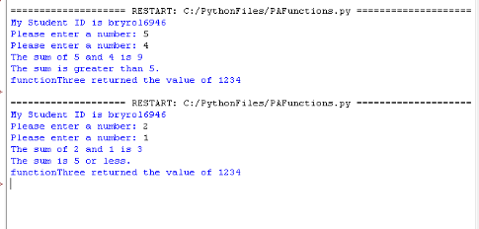

- The purpose of a function is to organize code and make it reusable within the program.

- The reason a programmer may pass more than one parameter to a function is the function may need more info such as variables/values to complete its task.

- The programmer can store the returned value in a variable which can be used when calling the function.

- The print statement prints a message on the console. The f makes it a f-string which allows the value stored in num1 be inserted into the print statement where num1 is called.

- Once myFunction() is called and executed, the program goes back to the main function and continues the program after myFunction().

